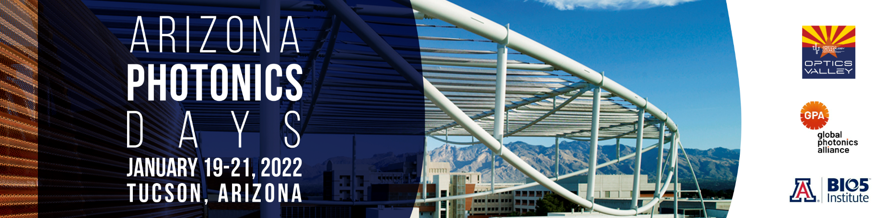
CALL FOR PAPERS

Abstract deadline for Arizona Photonics Days 2022 is November 15, 2021

Optics Valley invites industry scientists and engineers from around the world to submit abstracts for presentation at the 5th Arizona Photonics Days. This international in-person conference, held January 19-21, 2022, in Tucson, Arizona, connects optics and photonics industry peers and leaders for technical presentations, industry trend discussions, and business-building meetings.

Submission Overview
- Papers should inform on techniques and processes that expand the scope of optics and photonics technologies in industrial and commercial applications in these five conference tracks:
- Quantum Information Science
- Biomedical Technology
- Astronomy
- Sensing and Metrology
- Laser Technology
- One presenter per paper will be allowed 20 minutes plus 10 minutes for audience questions
- Authors will be notified of acceptance on or before December 1, 2021
- Presentation format is PowerPoint; guidelines to be provided at acceptance
- Final presentations are due January 5, 2022

Submission Requirements
- Send these four items by November 15, 2021 to info@opticsvalleyaz.org with “APD 2022 Abstract” in the subject line:
- Presentation title
- Author and presenter information
- Abstract (250 words or less)
- Conference track: Quantum Information Science, Biomedical Technology, Astronomy, Sensing and Metrology, and Laser Technology
- Once accepted, presenter will register for the conference at applicable rates and author(s) and presenter agree that:
- Conference organizers will make all presentations and/or manuscripts available to all attendees after the conference
- Attendees may photograph the presenters and presentations for their own use or for sharing on the Internet and social media
- Conference organizers may use photographs that include the presenter and/or presentation in post-conference materials and promotional materials for future conferences

Submit your abstract by November 15, 2021

info@opticsvalleyaz.org

