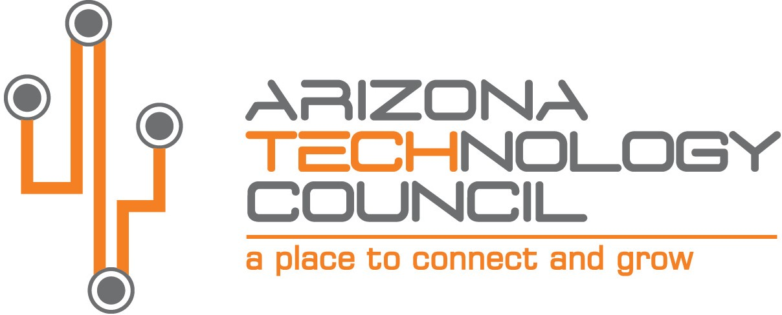
NOMINATION DEADLINE IS TUESDAY, AUGUST 31, 2021.

2021 SOUTHERN ARIZONA TECH + BUSINESS EXPO

Sustainability Award

NOMINATION INFORMATION

Nominee Company name
Company address
City State Zip
Company Website
Nominator Contact
Contact Title
Contact Phone Number Contact Email

The SUSTAINABILITY AWARD is presented to a company or business that seeks to highlight sustainable practices, initiatives or programs by adopting practices without compromising people, the planet, or the economy. Company can demonstrate how their programs serve as good examples for other institutions and must meet the following requirements:

- Company or business unit must be based in Southern Arizona.
- Self-nomination is allowed.

Please submit nominations via email to: jneilson@aztechcouncil.org.

Provide a brief description of the company.

What sustainable programs or initiatives has this company created, deployed and/or expanded?

Provide any additional information on the company or its practices (articles, awards, etc.).

