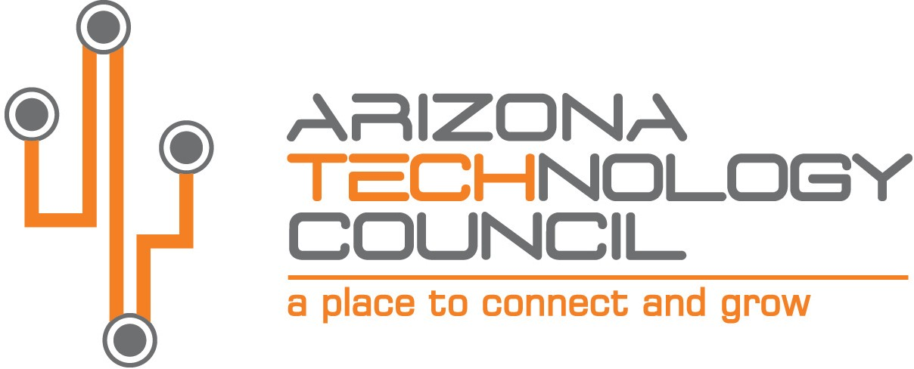
NOMINATION DEADLINE IS TUESDAY, AUGUST 31, 2021.

2021 SOUTHERN ARIZONA TECH + BUSINESS EXPO

Startup of the Year Award

NOMINATION INFORMATION

Nominee Company name
Company address
City State Zip
Company Website
Nominator Contact
Contact Title
Contact Phone Number Contact Email

The STARTUP OF THE YEAR AWARD is presented to a company or business unit in a technology industry that has achieved significant business success, and technical innovation or scientific achievement in the past calendar year and meets the following requirements:

- Company or business unit must be based in Southern Arizona.
- Company must have been created and/or funded within the past 24 months.
- Must be generating revenue and/or already receiving funding.
- Innovation must be developed in Arizona.
- Profitability is not a requirement.

Please submit nominations via email to: jneilson@aztechcouncil.org.

Provide a brief description of the company, include date created and funded and by whom.

Describe future plans/goals/strategies for this company and any obstacles the company must overcome to continue the company’s growth.

Provide any additional information on the company or its practices (articles, awards, etc.).

