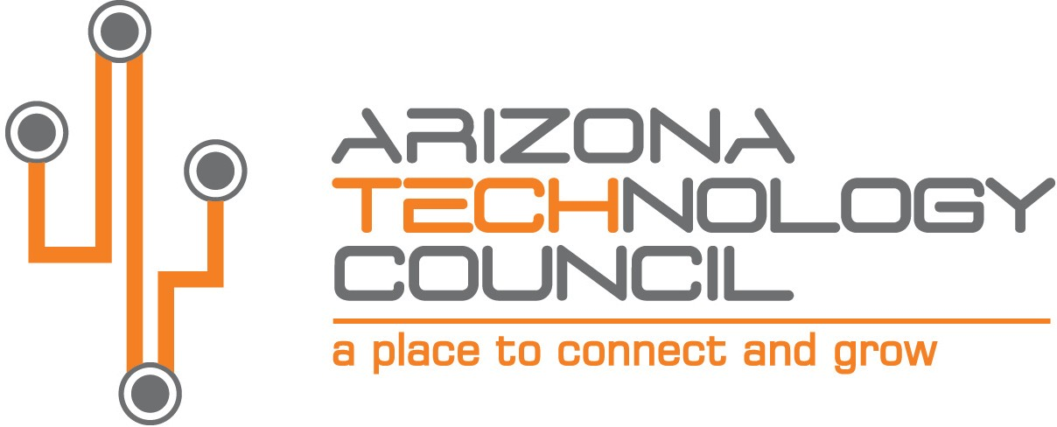
NOMINATION DEADLINE IS TUESDAY, AUGUST 31, 2021.

2021 SOUTHERN ARIZONA TECH + BUSINESS EXPO

Southern Arizona Member Organization of the Year Award

NOMINATION INFORMATION

Nominee Company name
Company address
City State Zip
Company Website
Nominator Contact
Contact Title
Contact Phone Number Contact Email

The SOUTHERN ARIZONA MEMBER ORGANIZATION OF THE YEAR AWARD is presented to a member company or organization that has demonstrated support of AZTC’s vision statement: to be the driving force behind making AZ the fastest growing technology hub in the nation; connecting and empowering Arizona’s technology community. The company or organization has made a significant contribution to the AZTC by helping drive overall growth and mission impact, particularly in Southern Arizona. Any business or organization representing industry, government, or academia may be nominated.

- Company or business unit must be based in Southern Arizona.
- Company must have been an AZTC member for at least the past 12 months.
- Company can demonstrate its investment in Southern AZ workforce, supply chain, and/or initiatives.

Please submit nominations via email to: jneilson@aztechcouncil.org.

Provide a brief description of the company and its contribution to Southern Arizona’s tech industry.

Describe how the company is involved with AZTC and supports its vision statement (see above).

Provide any additional information on the company or its practices (articles, awards, etc.).

