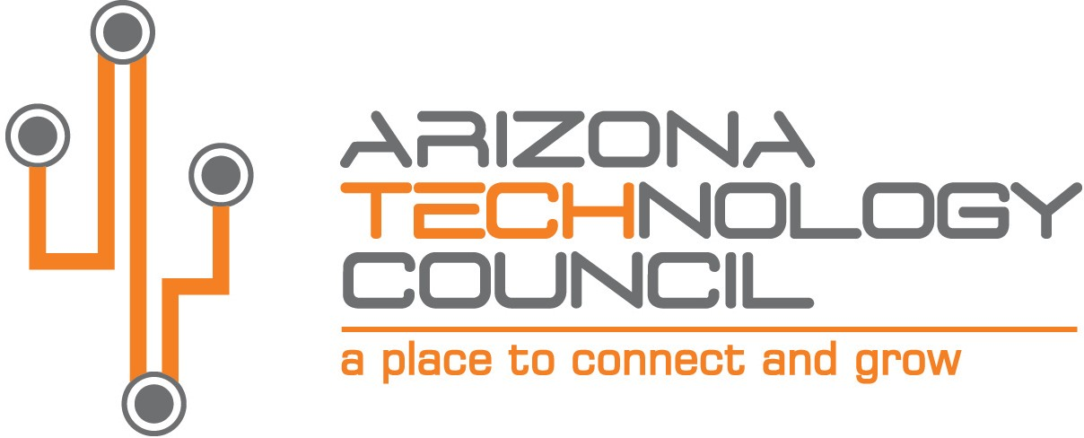
NOMINATION DEADLINE IS TUESDAY, AUGUST 31, 2021.

2021 SOUTHERN ARIZONA TECH + BUSINESS EXPO

Manufacturer of the Year

NOMINATION INFORMATION

Nominee Company name
Company address
City State Zip
Company Website
Nominator Contact
Contact Title
Contact Phone Number Contact Email

The MANUFACTURER OF THE YEAR AWARD is presented to a company or business that demonstrates leadership as a manufacturer in the region with a new process or product, and involvement with the business and wider community of Southern Arizona and meets the following requirements:

- Company or business unit must be based in Southern Arizona.
- Company has expanded or invested in local economy and work force.
- Company demonstrates commitment to local supply chain (where applicable).
- Self-nomination is allowed.

Please submit nominations via email to: jneilson@aztechcouncil.org.

Provide a brief description of the company. What do they manufacture?

How does this company show commitment to the Southern AZ region and invest locally?

Provide any additional information on the company or production (website, articles, etc.).

