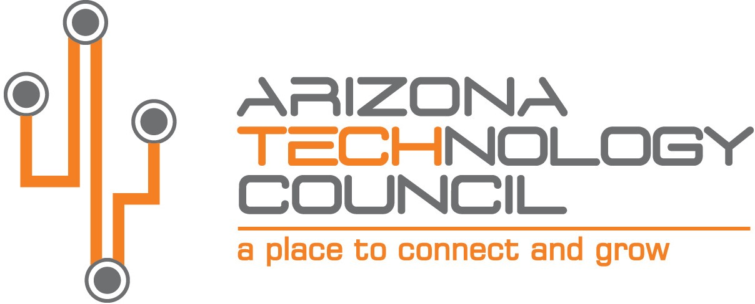
NOMINATION DEADLINE IS TUESDAY, AUGUST 31, 2021.

2021 SOUTHERN ARIZONA TECH + BUSINESS EXPO

Innovation Leader of the Year

NOMINATION INFORMATION

Nominee Company name
Company address
City State Zip
Company Website
Nominator Contact
Contact Title
Contact Phone Number Contact Email

The INNOVATOR OF THE YEAR AWARD is presented to a company or business that has made a significant contribution to the Southern Arizona technology community and/or significant contribution to advancing or transforming an industry sector. The company meets the following requirements:

- Company or business unit must be based in Southern Arizona.
- Innovation must be technological in nature or involve technology and be leading edge.
- Innovation must be developed in Arizona.
- Self-nomination is allowed.

Please submit nominations via email to: jneilson@aztechcouncil.org.

Provide a brief description of the company.

What makes this company or its product innovative and unique? Any awards received?

Provide any additional information on the company or innovation (website, articles, etc.)

