Main banners: approx. 1920x512 Horizontal Podium graphic: 512x512 Vertical Podium graphic: 700x512
*Logos should be .jpg or .png with transparent background if you want the background color to
show through. Background colors are customizable.
*Small Image Boards: 512x512 .jpg

Web Boards: 4:3 aspect ratio. 1024x768 ideal. 2048x1536 max 32 MB limit.
*YouTube Video recommended

Main Banner

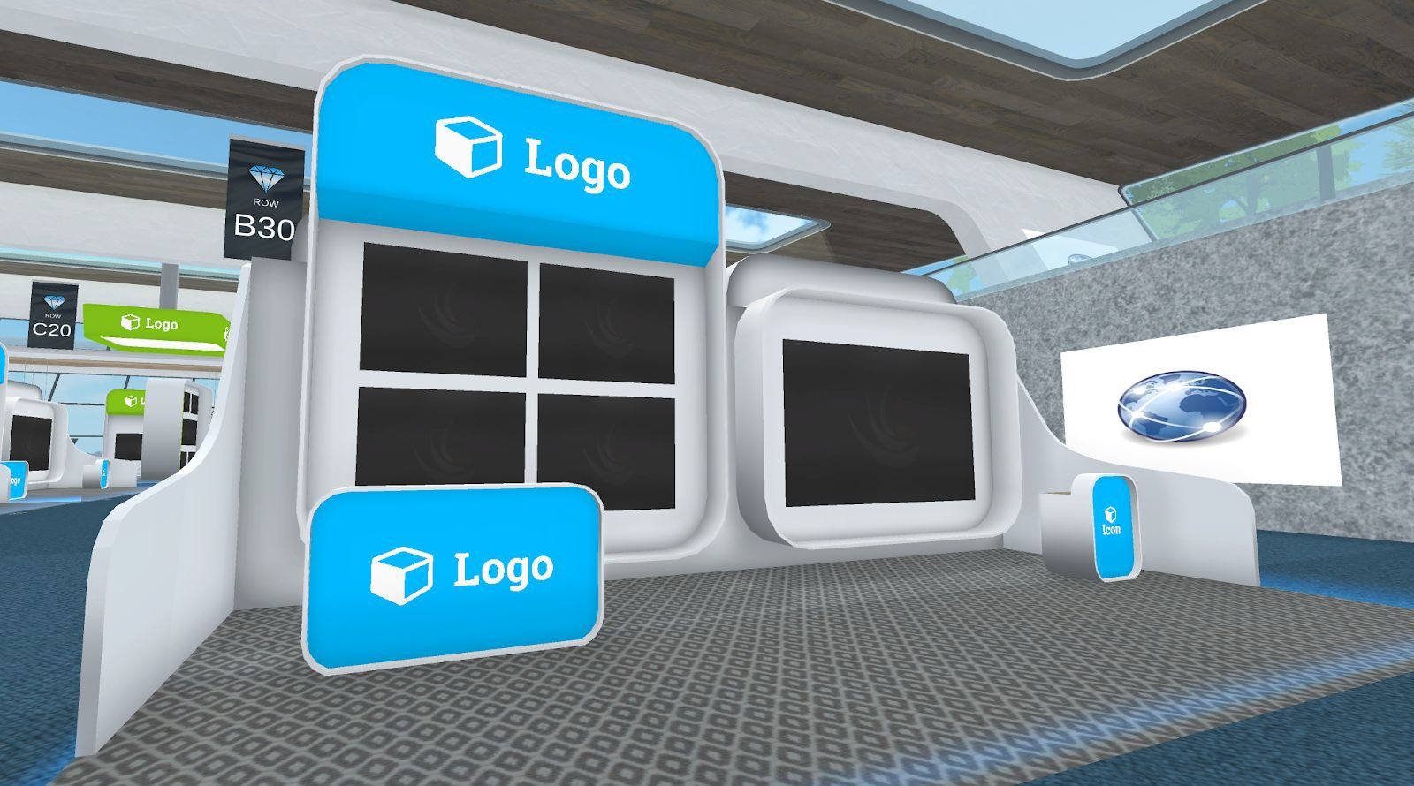Small Image Boards

Web Board

Vertical Podium

Horizontal Podium

Virbela software will conform

