David Woody
Senior Vice President
Network Modernization, Network Solutions and Operations

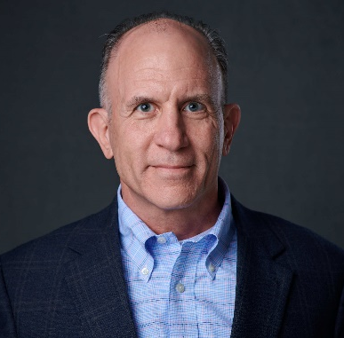
David Woody is Senior Vice President of NeMo (Network Modernization), within the Network Solutions and Operations team at American Express. In this role, David is helping to modernize the Network, enabling us to meet the unique needs of our Merchants, Acquirers, Proprietary Issuers and Bank Partners, and to enable a wider variety of payments across the Network.

David has an extensive background with American Express Technology that spans 25+ years. His previous responsibilities include serving as SVP and Unit CIO of Global Risk, Finance Technology & Transformation where he provided CIO support to Global Risk, Banking & Compliance and Finance, as well as the General Counsel’s Office and Internal Audit, and provided governance for all technology transformation initiatives, including the Technology Strategy. He also led the Data Center Program, building new world-class data center facilities to provide global hosting, increased agility and service quality. Prior to that, he served as the Unit CIO for Risk, Information Management & Banking, where he was responsible for worldwide credit, risk, fraud, authorizations, customer marketing, information management and banking technology systems.

David is a co-lead for the Phoenix Market Executive Team. He has a B.S. in Computer Information Systems from Arizona State University, where he serves as the Technology Sponsor for the Campus Recruitment Program. David is also the Executive Sponsor at American Express for Year Up, and serves on the Board of Directors for the Arizona Technology Council.

